**Week d/t**

Oefenblaadje:

|  |  |
| --- | --- |
|  |  |
|  |  |
|  |  |
|  |  |
|  |  |
|  |  |
|  |  |
|  |  |
|  |  |
|  |  |
|  |  |
|  |  |
|  |  |
|  |  |
|  |  |
|  |  |
|  |  |
|  |  |
|  |  |
|  |  |

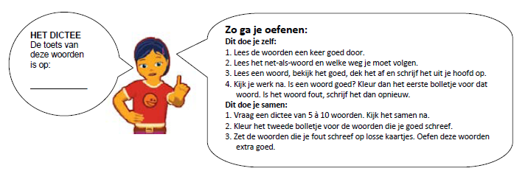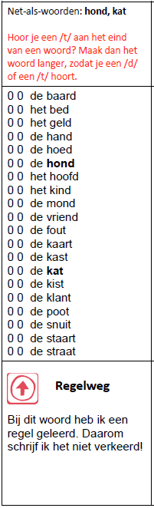

0 0 hond

0 0 woord

0 0 bord

0 0 hoed

0 0 kwaad

0 0 mand

0 0 rand

0 0 draad

0 0 baard

0 0 tand

0 0 kat

0 0 krijt

0 0 grot

0 0 zout

0 0 pit

0 0 taart

0 0 krant

0 0 staart

0 0 snuit

0 0 straat