**Week 25**

Oefenblaadje:

|  |  |
| --- | --- |
|  |  |
|  |  |
|  |  |
|  |  |
|  |  |
|  |  |
|  |  |
|  |  |
|  |  |
|  |  |
|  |  |
|  |  |
|  |  |
|  |  |
|  |  |
|  |  |
|  |  |
|  |  |
|  |  |
|  |  |

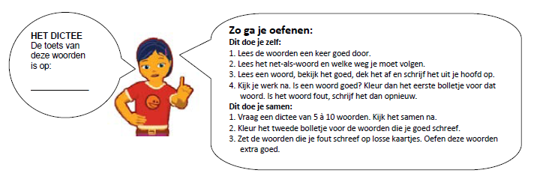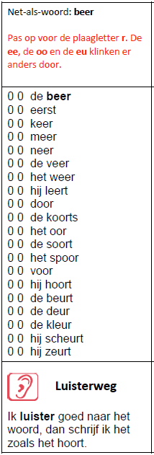 Oefenblaadje: